Assignment 1

***Important notes:***

***Exceptional handling should be done where needed.***

***Pictures are just for the reference you can create your own style of webpage except for question 6, question 10***

Q1- Create a webpage that hide a text on the click of a button.

Q2- Create a webpage that changes image on the click of a button.

Q3- Create a webpage that changes the text of a paragraph on the click of a button.

Q4- Create a webpage that alerts a warning “Error” when a button is clicked.

Q5- Create a webpage that toggles a text (show and hide) on the click of a button.

Q6- Write a JavaScript code in which when a user clicks on **Explore** button, the user is directed to Fill your interest page.



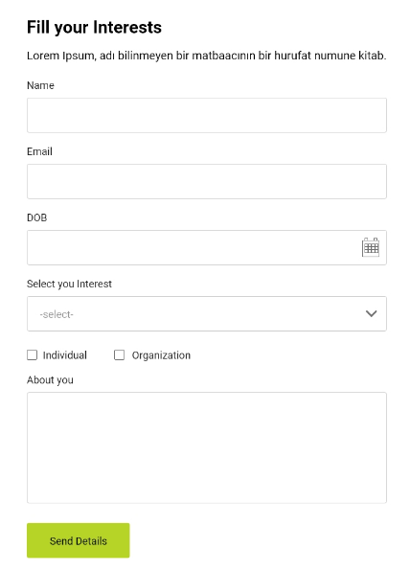

Q7- Create 2 buttons that subtract and add a number from the display.

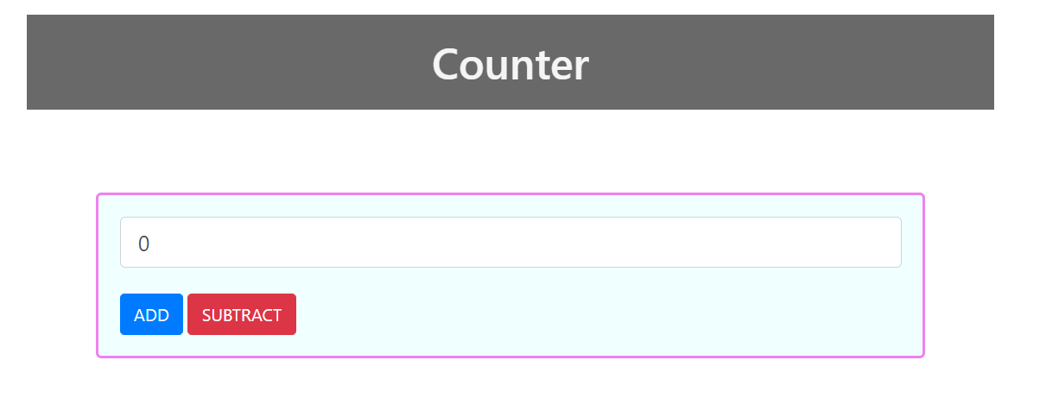

Q8- Create a webpage in which the user inputs First name, Last Name, and Name format(dropdown) ({firstname, lastname} or {lastname, first name}) and then display the name according to the name format.

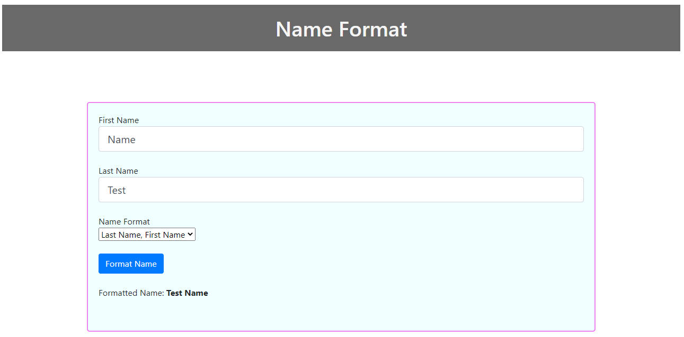

Q9- Create a webpage in which the user inputs something in the text area and the function displays the number of characters in the text area.

Q10- Write a JavaScript code to add validations in the Name, Email, DOB and Select your Interest

Name:

1. Name Textbox have the limit to 50 characters else it will show the error below the text box “Character Limit Exceeds “, when the **Send Details** Button is clicked.
2. If the Name Textbox is empty, it should show an error below the textbox “Name cannot be empty” when the **Send Details** button is clicked.

Email:

1. If the Email Textbox is empty, it should show an error below the textbox “Email cannot be empty” when the **Send Details** button is clicked.
2. Email should have one @ (there should be some test before and after @) else show an error below the textbox “Invalid Email”.

DOB:

1. If the DOB Textbox is empty, it should show an error below the textbox “DOB cannot be empty” when the **Send Details** button is clicked.
2. The User should be 13 years or older else show an error below the textbox “Hello Kid! You are too young for this”.

Select your interest:

1. If the Select your interest Dropdown is not selected, it should show an error below the dropdown “Please select the value to proceed” when the **Send Details** button is clicked.



Use Inline and internal JavaScript and Arrow function for this. Also use try catch in this.

Q11- Create a tax calculator based on these calculations:

* Where the yearly taxable salary income does not exceed Rs. 600,000 the rate of income tax is 0%.
* Where the yearly taxable salary income exceeds Rs. 600,000 but does not exceed Rs. 1,200,000 the rate of income tax is 2.5% of the amount exceeding Rs. 600,000
* Where the yearly taxable salary income exceeds Rs. 1,200,000 but does not exceed Rs. 2,400,000 the rate of income tax is Rs. 15,000+12.5% of the amount exceeding Rs. 1,200,000.
* Where the yearly taxable salary income exceeds Rs. 2,400,000 but does not exceed Rs. 3,600,000 the rate of income tax is Rs. 165,000 + 20% of the amount exceeding Rs. 2,400,000.
* Where the yearly taxable salary income exceeds Rs. 3,600,000 but does not exceed Rs. 6,000,000 the rate of income tax is Rs. 405,000 + 25% of the amount exceeding Rs. 3,600,000.
* Where the yearly taxable salary income exceeds Rs. 6,000,000 but does not exceed Rs. 12,000,000 the rate of income tax is Rs. 1,005,000 + 32.5% of the amount exceeding Rs. 6,000,000.
* Where the yearly taxable salary income exceeds Rs. 12,000,000 the rate of income tax is Rs. 2,955,000 + 35% of the amount exceeding Rs. 12,000,000.

Input the monthly salary and output the monthly taxable amount, monthly salary after tax, yearly tax and yearly income after tax**. No button should be used for calculating the tax, the value should be calculated when the value on the textbox is changed.**

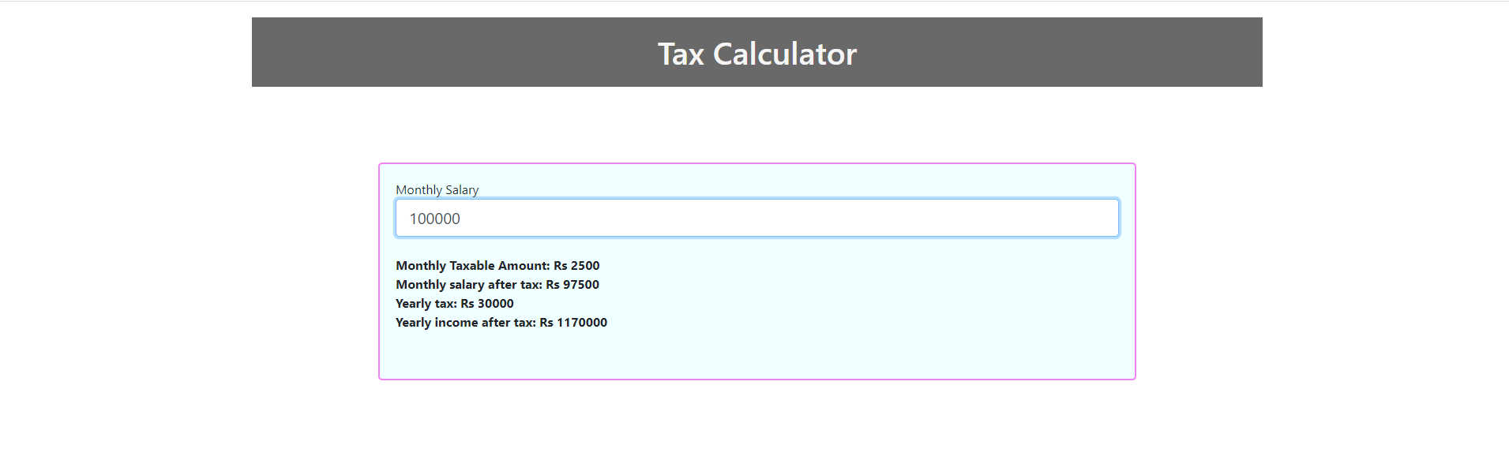

Q12- Create a login page and verify the username and password with the hardcoded values that are already present in the code. If the login is successful, redirect them to another page. Otherwise show them the errors.

